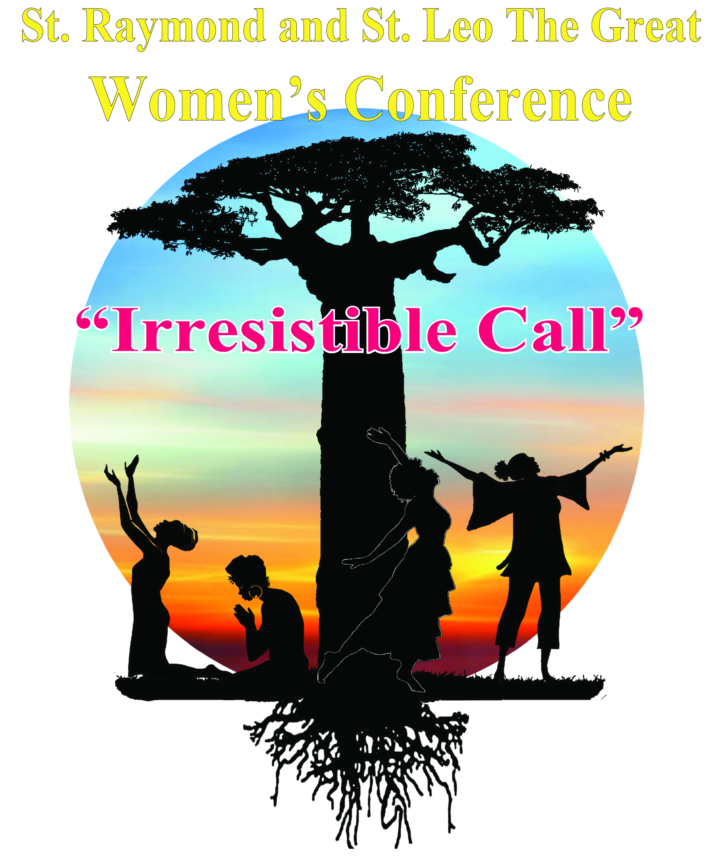

St. Raymond and St. Leo the Great 3rd Annual Women’s Conference 2017
“Irresistible Call”

January 14-15, 2017 Corpus Christi-Epiphany Community Resource Center

THEME: “If God is for us who can be against us” Romans 8:31

PURPOSE: THE PURPOSE OF THIS CONFERENCE IS TO CELBRATE WOMANHOOD AND THE MANY UNIQUE GOD-GIVEN GIFTS OF EACH WOMAN. WE SEEK TO GROW IN MIND, BODY AND SPIRIT ENABLING US TO BETTER SERVE GOD, FAMILY AND EACH OTHER.

PLEASE JOIN US!

The 3rd Annual Women’s Conference hosted by St. Raymond and St. Leo the Great promises to continue to be a unique experience for women across the New Orleans area. This exciting event will take place January 14-15, 2017 at Corpus Christi-Epiphany Community Resource Center 2022 St. Bernard Ave. N.O., La 70116.
You are invited to display and sell materials from your organization. The fee is $100.00 per unit. A deposit of $50.00 per unit is required with your application, no later than November 18, 2016. The balance is due on or before December 18, 2016. Booths may be set-up beginning Saturday morning January 14, 2017 at 7:00 AM and dismantled on Saturday after the conference ends. In addition, you are allowed to display and sell your items on Sunday.

Please complete the attached Registration Form, and mail it along with check, money order or certified cashier’s check made payable to St. Raymond and St. Leo the Great Church (please write “2017 Women’s Conference” on memo line).
Return both to:
St. Raymond and St. Leo the Great Church
2916 Paris Ave
New Orleans, LA. 70119
Attention: 2017 Women’s Conference

For additional information, contact Cynthia Shelton at (504) 324-6270 or email us at srslwomensconference @yahoo.com

We look forward to seeing you!

